NAME:Sai Kulwanth Akkina H.NO:2303a51580 BATCH:26
SCHOOL OF COMPUTER SCIENCE AND ARTIFICIAL INTELLIGENCE |  |  |  |  | DEPARTMENT OF COMPUTER SCIENCE ENGINEERING
Program Name: B. Tech |  |  |  | Assignment Type: Lab |  |  | Academic Year:2025-2026
Course Coordinator Name |  |  |  | Dr. Rishabh Mittal
Instructor(s) Name
  Mr. S Naresh Kumar
  Ms. B. Swathi
  Dr. Sasanko Shekhar Gantayat
  Mr. Md Sallauddin
  Dr. Mathivanan
  Mr. Y Srikanth
  Ms. N Shilpa
  Dr. Rishabh Mittal (Coordinator)
  Dr. R. Prashant Kumar
  Mr. Ankushavali MD
  Mr. B Viswanath
  Ms. Sujitha Reddy
  Ms. A. Anitha
  Ms. M.Madhuri
  Ms. Katherashala Swetha
  Ms. Velpula sumalatha
  Mr. Bingi Raju
CourseCode |  |  | 23CS002PC304 | Course Title |  | AI Assisted Coding
Year/Sem |  |  | III/II | Regulation |  | R23
Date and Day  of Assignment |  |  | Week1 – Thursday | Time(s) |  | 23CSBTB01 To 23CSBTB52
Duration |  |  | 2 Hours | Applicable to  Batches |  | All batches
Assignment Number:1.3(Present assignment number)/24(Total number of assignments)
 | Q.No. | Question |  |  |  |  |  | Expected Time  to complete
 | 1 | Lab 1: Environment Setup – GitHub Copilot and VS Code Integration + Understanding AI-assisted Coding Workflow  Lab Objectives:  - To install and configure GitHub Copilot in Visual Studio Code.  - To explore AI-assisted code generation using GitHub Copilot.  - To analyze the accuracy and effectiveness of Copilot's code suggestions.  - To understand prompt-based programming using comments and code context  Lab Outcomes (LOs):  After completing this lab, students will be able to:  - Set up GitHub Copilot in VS Code successfully.  - Use inline comments and context to generate code with Copilot.  - Evaluate AI-generated code for correctness and readability.  - Compare code suggestions based on different prompts and programming styles.  Task 0  - Install and configure GitHub Copilot in VS Code. Take screenshots of each step.  Expected Output  - Install and configure GitHub Copilot in VS Code. Take screenshots of each step.  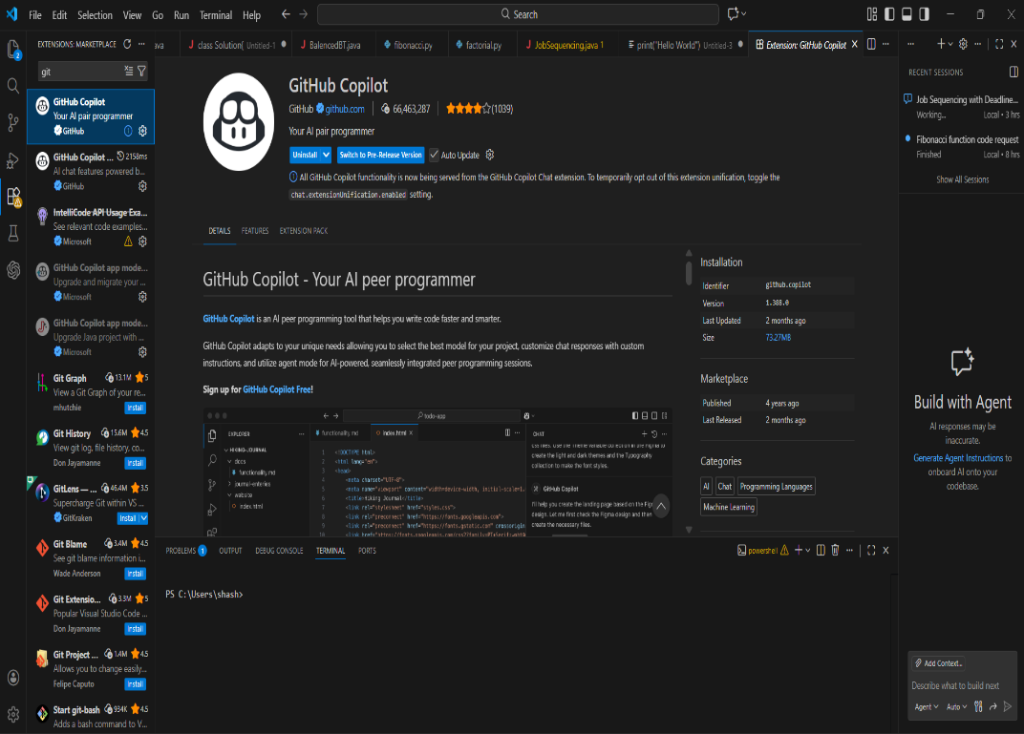  Task 1: AI-Generated Logic Without Modularization (Prime Number Check Without Functions)  - Scenario  - You are developing a basic validation script for a numerical learning application.  - Task Description  Use GitHub Copilot to generate a Python program that:  - Checks whether a given number is prime  - Accepts user input  - Implements logic directly in the main code  - Does not use any user-defined functions  - Expected Output  - Correct prime / non-prime result  - Screenshots showing Copilot-generated code suggestions  - Sample inputs and outputs  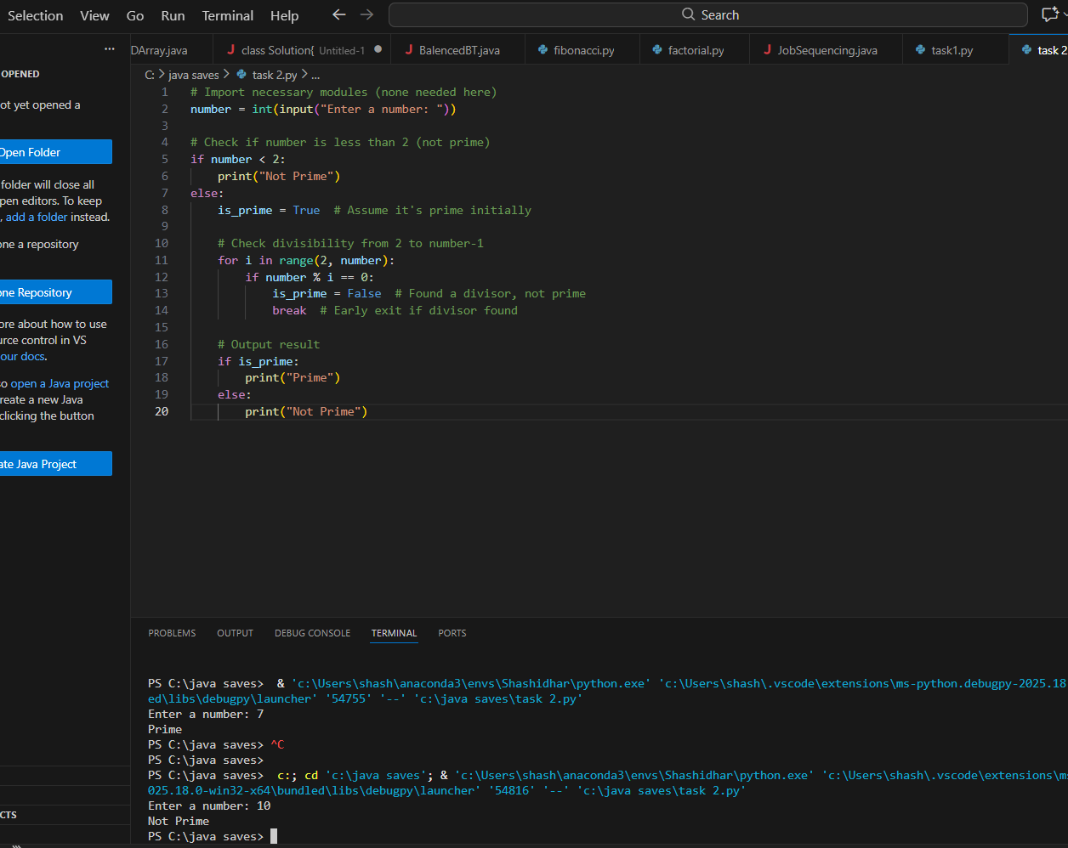  Task 2: Efficiency & Logic Optimization (Cleanup)  - Scenario  The script must handle larger input values efficiently.  - Task Description  Review the Copilot-generated code from Task 1 and improve it by:  - Reducing unnecessary iterations  - Optimizing the loop range (e.g., early termination)  - Improving readability  - Use Copilot prompts like:  - “Optimize prime number checking logic”  - “Improve efficiency of this code”  Hint:  Prompt Copilot with phrases like  “optimize this code”, “simplify logic”, or “make it more readable”  - Expected Output  - Original and optimized code versions  - Explanation of how the improvements reduce time complexity  - 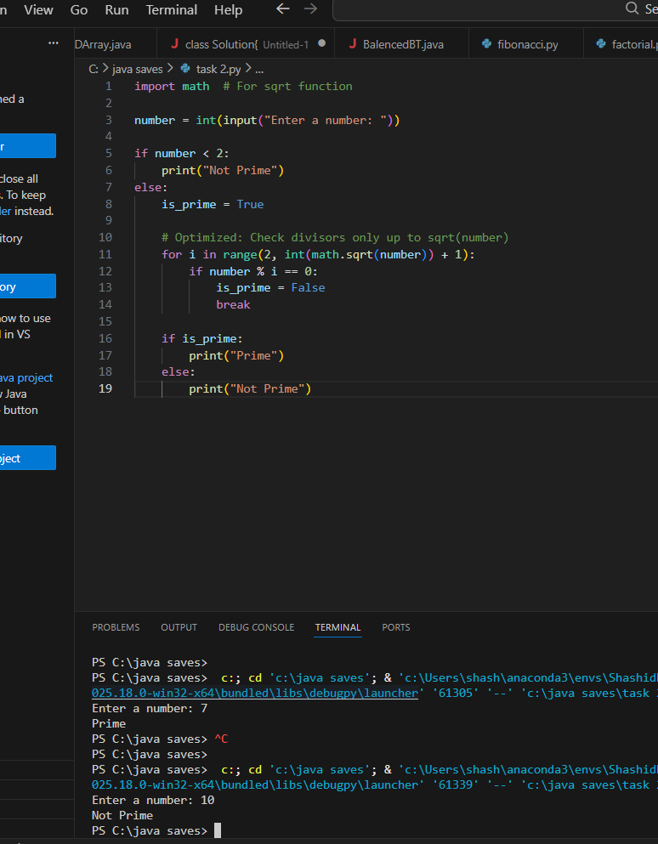  Task 3: Modular Design Using AI Assistance (Prime Number Check Using Functions)  - Scenario  The prime-checking logic will be reused across multiple modules.  - Task Description  Use GitHub Copilot to generate a function-based Python program that:  - Uses a user-defined function to check primality  - Returns a Boolean value  - Includes meaningful comments (AI-assisted)  - Expected Output  - Correctly working prime-checking function  - Screenshots documenting Copilot’s function generation  - Sample test cases and outputs  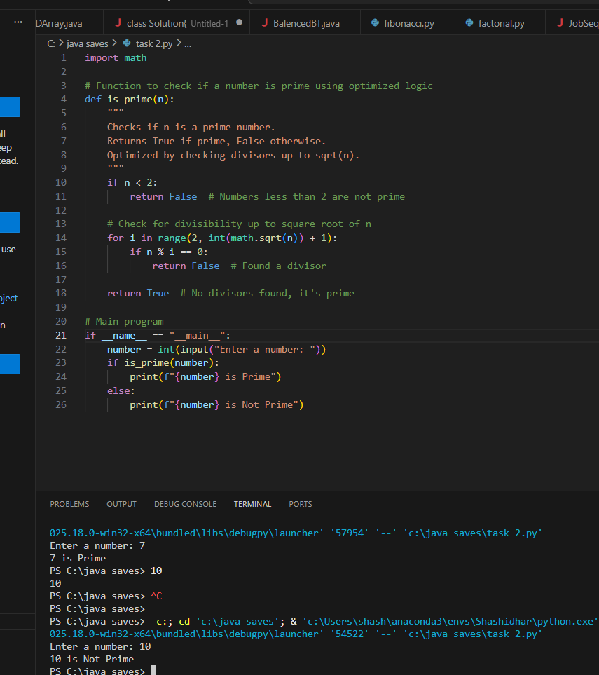  Task 4: Comparative Analysis –With vs Without Functions  - Scenario  You are participating in a technical review discussion.  - Task Description  Compare the Copilot-generated programs:  - Without functions (Task 1)  - With functions (Task 3)  - Analyze them based on:  - Code clarity  - Reusability  - Debugging ease  - Suitability for large-scale applications  - Expected Output  Comparison table or short analytical report  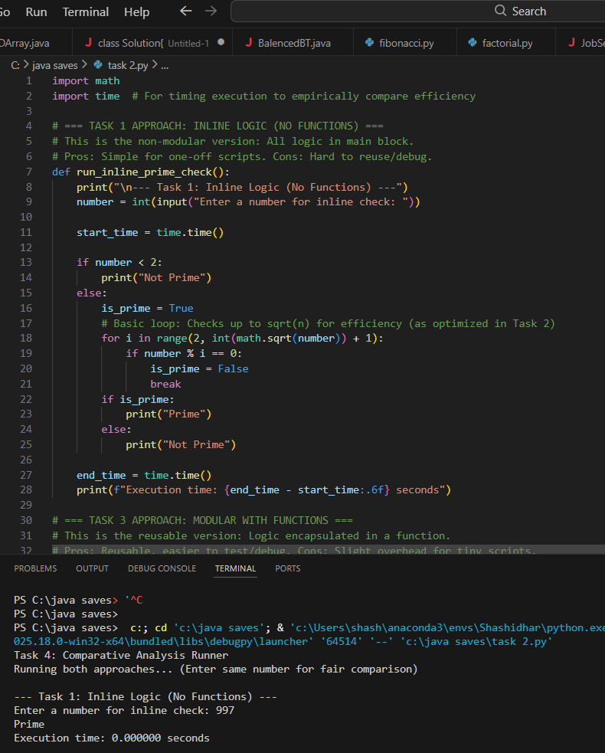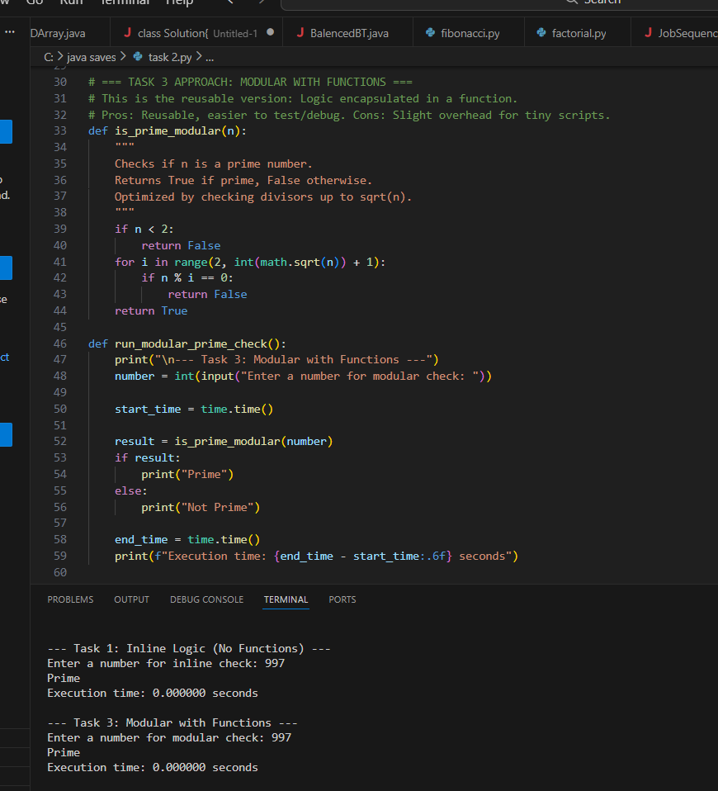  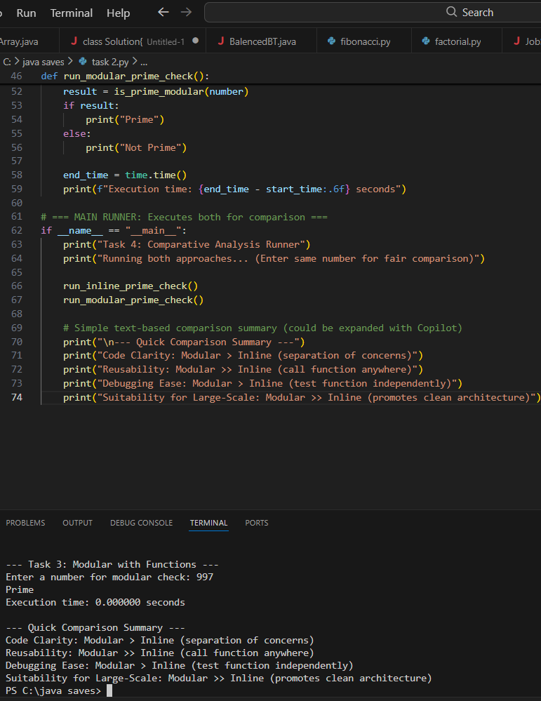  Task 5: AI-Generated Iterative vs Recursive Fibonacci Approaches (Different Algorithmic Approaches to Prime Checking)  - Scenario  Your mentor wants to evaluate how AI handles alternative logical strategies.  - Task Description  Prompt GitHub Copilot to generate:  - A basic divisibility check approach  - An optimized approach (e.g., checking up to √n)  - Expected Output  - Two correct implementations  - Comparison discussing:  - Execution flow  - Time complexity  - Performance for large inputs  - When each approach is appropriate  - 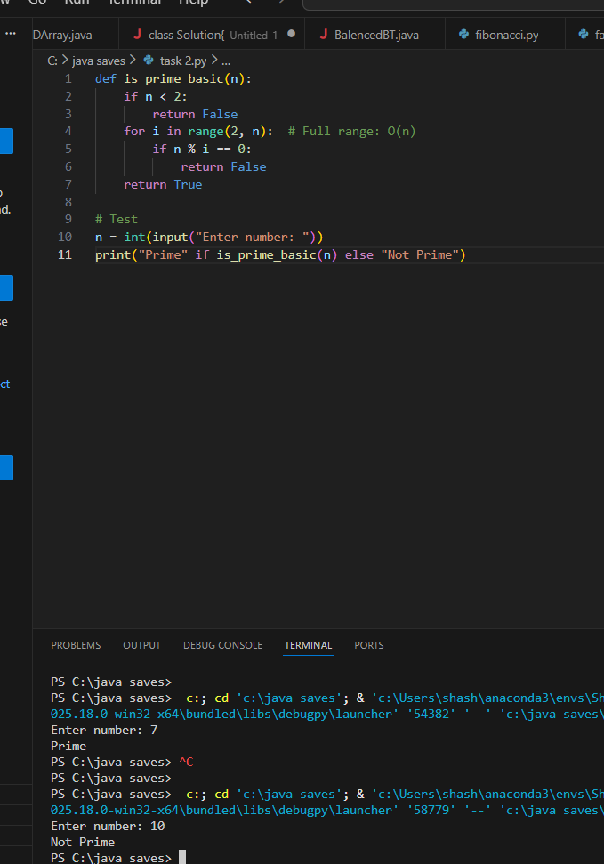  - 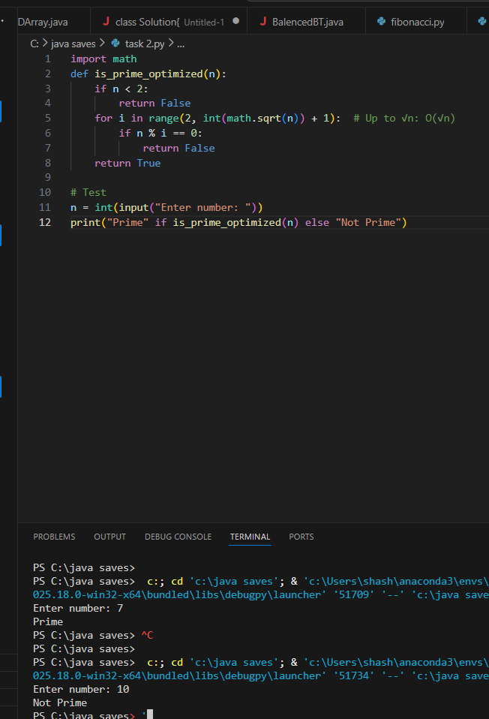  Note: Report should be submitted as a word document for all tasks in a single document with prompts, comments & code explanation, and output and if required, screenshots. |  |  |  |  |  | Week1 - Monday

